Project Part 1

First Release

Piratheesh Gunaseelan 100705676

Ayesha Haider 100869659

University of Ontario Institute of Technology
Faculty of Business and IT

Sheikh Ahmed Munieb

INFR 3120U - Web and Script Programming - Fall 2025

CalTrack

- Description of project:
CalTrack is a website that helps users track their daily caloric intake. It operates by having users input information pertaining to the food they consume through the day, and after submitting the information, it will be formatted into a table displaying the information entered so that users can easily see their progress. The information users can input at every entry includes: name of the food/dish, what time the food was eaten, how many calories in the food item, how much the food item consumed weighed (in grams), and a notes section. The point of this application is to help those wanting to track their calories for weight loss, weight gain, to get a better understanding of their eating habits, and any other way an individual may want to track their daily calories.

The first implementation of this project aims to achieve a functional CRUD format. This will be accomplished when users create new food entries, read them in a table on the landing page, update existing entries, and delete items. The hero button on the home page leads to the “track food item” form, and the landing page lists active meal entries. We’ll use Node.js/Express stack with server-side templates (EJS) as well as client side templates (JS) as well as MongoDB to store our users' data entries. And finally will host the website on Render, a live demonstration of the website can be found through the linked url and our tracked progress can be displayed on our GitHub Repo.

Logo:
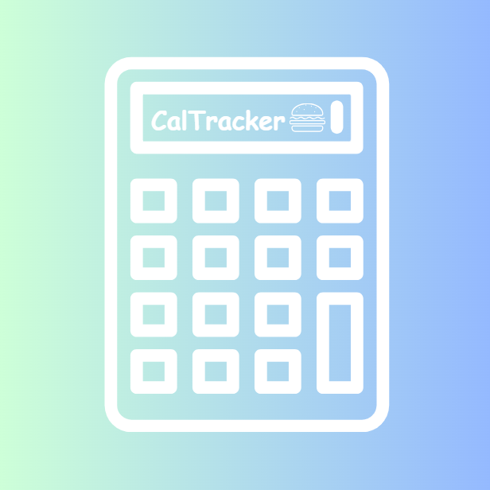

Who did what and how we divided the work:
- Ayesha’s Contribution:
- made the home page and I made the data be formatted into a table on the webpage. I also did the create and read part of the project as well as the video script and readme file.
- Clip of vs code (ayesha) show git ignore/env
  - After copying the assignment 2 code into this assignment folder I added a .env and git ignore. So that when I push my commits the username and password of mongodb isn't pushed into my public repo cuz that's a security risk. I told git to ignore my .env when pushing and put the uri link into the .env file.
  - Under the models folder under the meals folder I made a meal.js file which is responsible for showing the format of the entries I made on mongodb. From this format I need to perform the 4 crud operations. Then under the routes folder I added a meal.js file. This is responsible for the logic and controlling the meals database from this router. I tell my router what libraries I need under the meal.js file. To create/read/update/delete the data from the database, I use get parameter. Then I also use the post parameter to actually paste into the database the entries.
  - Then I made a file under the views folder called list.ejs so it makes an actual table on my webpage displaying the data in a readable format
  - Then i made a server folder and moved everything around in it to make it more tidy
  - Under the views folder I made an add.ejs file too. These are for adding a meal entry to the table/database. Under add.ejs we are making a form that allows us to add the text fields such as entering a date, the meal/food item you ate, the time you ate it etc.
- Piratheesh’s Contribution:
  - I made the actual meal page so that we didn't have to type in /add into the browser to see it. I also did the update and delete operations. Finally i cleaned up our code since originally we used assignment 2 as a framework to work off of so i deleted the unnecessary pages like about me projects and contact me. I also added the logo to the page as well as made a hero button on the homepage linking the user to the meals page. And I deployed the site onto render and edited the video.

- Clip of Vs code part from pira
  - Under views folder I go to list.ejs and add a button so that when you're on the homepage it can take you to the add form page without having to type in /add into the browser everytime
  - I also made edit and delete buttons if someone wants to edit a meal entry or delete a meal entry. These buttons dont have logic yet so i added that in the router and edit file
  - I made an edit.ejs file containing the same contents as the add file, but also extracted each textfield entry from the database so that i can edit them.
  - Under routes folder under the meal.js (router) I use the get and post operation.
  - Under edit.ejs i add the current value under each field so that it will bring me the current name of that entry (current entry of the date, meal type, time of consumption etc so that i can edit it)
  - In the router, meal.js I added the logic for deleting so that i can delete the entry again using the get and post operations. Using try I am trying to delete the id and then redirect the user back to the meals page
  - Since we used the skeleton from Assignment 2, the project originally included pages like About Me, Projects, and Contact Me. These weren’t needed for CalTrack, so I removed all the unnecessary pages and cleaned up the folder structure
  - After that, I added a button on the homepage that links directly to the Meals page. This way, users don’t have to type anything into the URL and they can just click the button and go straight to the entries.

Notes for readme
to put in repo readme
https://www.youtube.com/watch?v=b3ne4Mkadoc
Used this to do .env and .gitignore

Explain u used this for line 1 under db.js
https://www.npmjs.com/package/dotenv

Adding static logo
https://www.youtube.com/watch?v=CUQAt1xfUWI

Canva logo:
https://www.canva.com/design/DAG4cxTiX6w/6l7x4ZQ8FDwlEUCd5_L3rQ/edit

